Advanced Concepts in Pediatric TB: Part 2

Online Course

Southeastern National Tuberculosis Center University of Florida CME Office

Presented by
Ana Alvarez, MD  Associate Professor  Department of Pediatrics  University of Florida | Amina Ahmed, MD  Pediatric ID Specialist  Levine Children’s Hospital | Ayesha Mirza, MD  Associate Professor  Department of Pediatrics  University of Florida

Target Audience
The course is designed for physicians, nurses, pharmacists, and field staff who interact with pediatric patients.

Price
Free

Program Description
In this series on Pediatric TB, the Pediatric ID Board Certifying Examination Content is presented by expert
speakers via case-based, interactive webinars. The series goes beyond basic content while following the pediatric ID guidelines and is intended for a diverse audience, including pediatric infectious disease fellows and clinicians who diagnose and treat TB in children.

Requirements for Successful Completion
- This CME activity consists of an educational component (lecture videos in an electronic format, which is followed by a quiz).
- Certificates are awarded upon successful completion (80% proficiency) of the course.
- In order to receive credit, participants must complete the activities in their entirety.
- The University of Florida College of Medicine will report CME credit to CE Broker when applicable.
- Participants must complete online evaluation of the course in order to obtain CE/CME certificate.

Topics
- Clinical Disease and Evaluation
- TB and HIV

Learning Objectives

As a result of participation in this activity, participants should be able to:
- Understand the general principles of antimicrobial use in TB medications for infants and children, including pharmacokinetic principles of absorption, distribution, metabolism, half-life, clearance, elimination and monitoring for toxicity/efficacy
- Identify high priority groups of infants and children who should be tested and treated for LTBI and active TB disease and interpret results of tests for same
- Recognize the clinical and radiographic manifestations of pulmonary and extrapulmonary TB in infants and children, including lymphadenitis, meningitis & miliary TB

Registration
- Participants must have basic knowledge of tuberculosis.
- The course is free but you must pre-register to attend.
- Registration is available online at https://reg.distance.ufl.edu/reg/Activity/Details/d7c2259e894e4336b3694f7fc86a656d

Faculty Disclosure
Ana Alvarez disclosed that she has no relevant financial relationships. No one else in a position to control the content of this activity has any financial relationships to disclose.

Ayesha Mirza disclosed that she has no relevant financial relationships. No one else in a position to control the content of this activity has any financial relationships to disclose.

Amina Ahmed disclosed that she receives grant support from the CDC for latent tuberculosis research.

Continuing Medical Education Credit
Accreditation: The University of Florida College of Medicine is accredited by the Accreditation Council for Continuing Medical Education (ACCME) to provide continuing medical education for physicians.

Credit: The University of Florida College of Medicine designates this enduring material for a maximum of 2 AMA PRA Category 1 Credits™. Physicians should claim only the credit commensurate with the extent of their participation in the activity.

Release Date: January 1, 2019
Expiration Date: December 31, 2020

Continuing Education
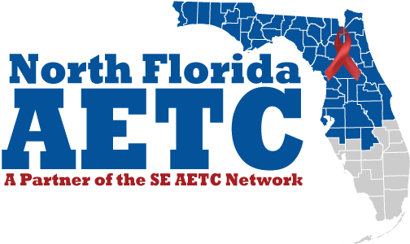
Accreditation: North Florida AIDS Education and Training Center is a Florida Board of Nursing, Clinical Social Work, Marriage, Family Therapy, Mental Health Counseling, Pharmacy and Dentistry approved provider of continuing education. CE Broker Provider ID #50-21098. For questions regarding CE or CME, please contact our Continuing Education Coordinator at aetc@medicine.ufl.edu or 352.273.7845.

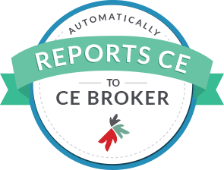
Credit: North Florida AIDS Education and Training Center designates this enduring material for this program meets the requirements for up to 2.00 contact hours. This program is registered in CE Broker, course number. Participants should claim only the credit commensurate with the extent of their participation in the activity.

Disclosure information and potential conflicts of interest: North Florida AIDS Education and Training Center (NF AETC) holds the standard that its continuing education programs should be free of commercial bias and conflict of interest. It is the policy of the NF AETC that each presenter and planning committee member of any CE activity must disclose any significant financial interest/arrangement or affiliation with corporate organizations whose products or services are being discussed in a presentation. All commercial support of an educational activity must also be disclosed to the conference attendees. Each individual with influence over content has completed a disclosure form indicating that neither they nor members of their immediate family have any financial interest, arrangement, or affiliation in any amount that could be perceived as a real or apparent conflict of interest related to the content or supporters involved with this activity within the past 12 months.

Questions
For more information, contact SNTC at sntc@medicine.ufl.edu or 888-265-7682.

