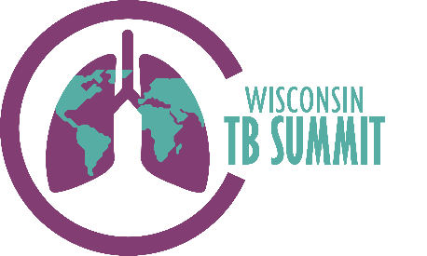
Wisconsin Virtual TB Summit

Tuesday, 3/15/22
10:00a – 11:00a Mental Health & TB: Assessing and supporting people with TB
Jen Perfetti LPC, IMH-E(IV), Mental health Consultant, PHMDC
11:00a – 11:45a Living with TB: A TB survivor shares his experience
Aruna Kallon MSP, PhD student, Educational Policy Studies, UW-Madison
Tuesday, 3/22/22
9:00a – 9:30a Wisconsin TB Program: updates & resources from the State
Claire Leback MPH, RN, Director, WI DHS TB Program
9:30a – 10:15a TB Epidemiology: Global, National, Wisconsin
Philip Wegner MPH, RN, Nurse Consultant, WI DHS TB Program
10:15a – 10:30a Southeastern National TB Center: A review of services, support, and resources
Karen Simpson MSHSE, Director SNTC
Tuesday, 3/29/22
12:30p – 3:30p BPaL: An overview & case studies from the field
Connie Haley, MD MPH, Southeastern National TB Center
Jessica Linzmeier BS, RN, Public Health Nurse, Marathon County Health Dep’t
Miva Yang BSN, RN, Public Health Nurse, Sheboygan County Health Dep’t
Philip Wegner MPH, RN, Nurse Consultant, WI DHS TB Program
Tuesday, 4/5/22
1:30p – 3:30p Extrapulmonary TB: An overview & case studies from the field
Connie Haley MD, MPH, Southeastern National TB Center
Kim Kringel RN, BS Public Health Nurse, Franklin Health Dep’t
Jessica Linzmeier RN, BS Public Health Nurse, Marathon County Health Dep’t
3:30p – 5:00p Pediatric TB: An overview & case studies from the field
Gina Brehm BS, RN, Public Health Nurse, City of Racine Health Dep’t
Anthony Garcia-Prats MD, MSc, Associate Professor, UW-Madison Dep’t of Pediatrics
Connor Stone BSN, RN, Public Health Nurse, Public Health Madison-Dane Co
Bryan Vonasek MD, Infectious Disease Fellow, UW-Madison Dep’t of Pediatrics
Tuesday, 4/12/22
9:00a – 10:30a The Secret Life of Sputum: From lung to lab
Philip Wegner RN, MPH, Nurse Consultant, WI State TB Program
Nate Simon, TB Laboratory Program Coordinator, WI State Lab of Hygiene
Tuesday, 4/19/22
9:00a – 10:00a Global TB work at the Local Level: Afghan immigrants in WI
Philip Wegner RN, MPH, Nurse Consultant, WI DHS TB Program
Tuesday, 4/26/22
9:00a – 10:30a Panel Discussion: Your TB questions answered
Claire Leback RN, MPH, Director, WI DHS TB Program
Kate Louther RN, MSN, TB Program Manager, Public Health Madison-Dane County Elizabeth Ann Misch, MD, Director, UW NTM/Mycobacterial Clinic
Nate Simon, TB Laboratory Program Coordinator, WI State Lab of Hygiene
Philip Wegner RN, MPH, Nurse Consultant, WI DHS TB Program

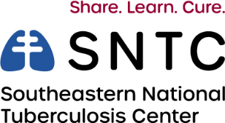
*All times are Central Time (CT)
